Tugas: Latihan soal pert 11
Kelas: 03TPLP023
Nama: Farsya Haikal Lesmana
Nim: 241011401494

- Buat suatu program animasi Stack yang menggunakan Linked List dalam mengelola data mahasiswa dengan struktur mahasiswa sbb : NAMA, NIM, GENDER, NILAI STRUKTUR DATA. Program dibuat dalam bentuk menu dengan pilihan : INSERT DATA, HAPUS DATA, CETAK DATA, EXIT.

Kodingan:
#include <iostream>
#include <string>
#include <windows.h>
#include <limits>
using namespace std;

struct Mahasiswa {
string nama;
string nim;
char gender;
float nilaistrukdat;
Mahasiswa* next;
};

class Stack {
private:
Mahasiswa* top;
int size;

public:
Stack() {
top = NULL;
size = 0;
}

~Stack() {
while (!isEmpty()) {
pop();
}
}

bool isEmpty() {
return top == NULL;
}

void push(string nama, string nim, char gender, float nilai) {
Mahasiswa* newMahasiswa = new Mahasiswa;
newMahasiswa->nama = nama;
newMahasiswa->nim = nim;
newMahasiswa->gender = gender;
newMahasiswa->nilaistrukdat = nilai;
newMahasiswa->next = top;
top = newMahasiswa;
size++;
}

void pop() {
if (isEmpty()) {
cout << "Stack kosong!" << endl;
return;
}
Mahasiswa* temp = top;
top = top->next;
delete temp;
size--;
}

Mahasiswa* peek() {
if (isEmpty()) {
return NULL;
}
return top;
}

int getSize() {
return size;
}

void display() {
if (isEmpty()) {
cout << "Stack kosong!" << endl;
return;
}

Mahasiswa* current = top;
int counter = 1;
while (current != NULL) {
cout << "Data " << counter << ":" << endl;
cout << "Nama: " << current->nama << endl;
cout << "NIM: " << current->nim << endl;
cout << "Gender: " << current->gender << endl;
cout << "Nilai Struktur Data: " << current->nilaistrukdat << endl;
cout << "------------------------" << endl;
current = current->next;
counter++;
}
}
};

void loading(string pesan) {
cout << pesan;
for(int i = 0; i < 3; i++) {
cout << ".";
Sleep(500);
}
cout << endl;
}

void clearInputBuffer() {
cin.clear();
cin.ignore(numeric_limits<streamsize>::max(), '\n');
}

int main() {
Stack stack;
int pilihan;

do {
cout << "\n=== PROGRAM STACK MAHASISWA ===" << endl;
cout << "1. Tambah Data Mahasiswa" << endl;
cout << "2. Hapus Data Teratas" << endl;
cout << "3. Lihat Data Teratas" << endl;
cout << "4. Tampilkan Semua Data" << endl;
cout << "5. Jumlah Data dalam Stack" << endl;
cout << "0. Keluar" << endl;
cout << "Pilihan: ";
cin >> pilihan;

switch(pilihan) {
case 1: {
string nama, nim;
char gender;
float nilai;

clearInputBuffer();
cout << "Masukkan Nama: ";
getline(cin, nama);
cout << "Masukkan NIM: ";
getline(cin, nim);
cout << "Masukkan Gender (L/P): ";
cin >> gender;
cout << "Masukkan Nilai Struktur Data: ";
cin >> nilai;

stack.push(nama, nim, gender, nilai);
loading("Menambahkan data");
cout << "Data berhasil ditambahkan!" << endl;
break;
}
case 2:
if (!stack.isEmpty()) {
stack.pop();
loading("Menghapus data");
cout << "Data teratas berhasil dihapus!" << endl;
} else {
cout << "Stack kosong!" << endl;
}
break;
case 3: {
Mahasiswa* topData = stack.peek();
if (topData != NULL) {
cout << "\nData Teratas:" << endl;
cout << "Nama: " << topData->nama << endl;
cout << "NIM: " << topData->nim << endl;
cout << "Gender: " << topData->gender << endl;
cout << "Nilai Struktur Data: " << topData->nilaistrukdat << endl;
} else {
cout << "Stack kosong!" << endl;
}
break;
}
case 4:
cout << "\nData dalam Stack:" << endl;
stack.display();
break;
case 5:
cout << "Jumlah data dalam stack: " << stack.getSize() << endl;
break;
case 0:
loading("Keluar dari program");
cout << "Terima kasih!" << endl;
break;
default:
cout << "Pilihan tidak valid!" << endl;
}
} while (pilihan != 0);

return 0;
}

Hasil output:

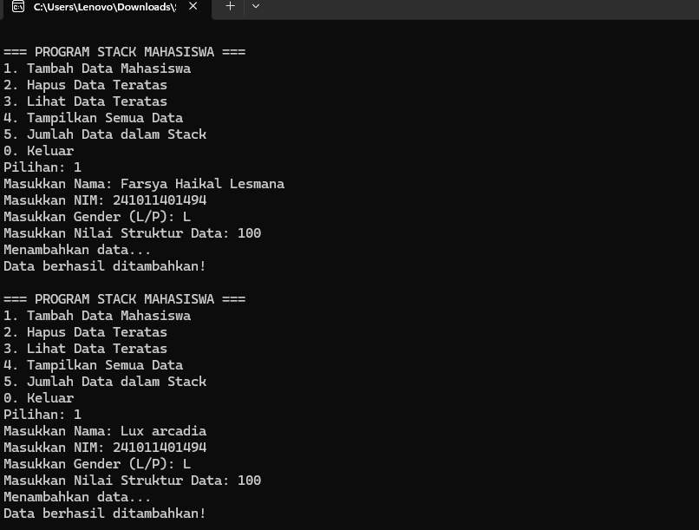

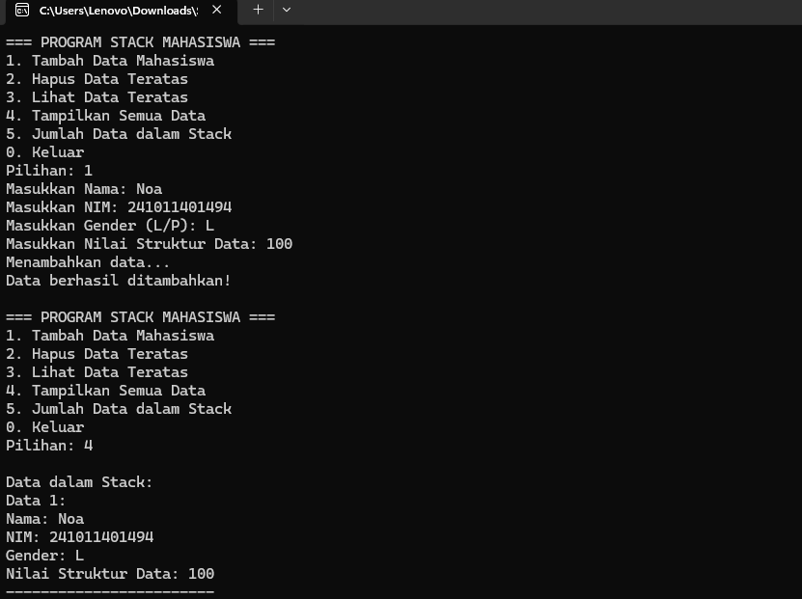

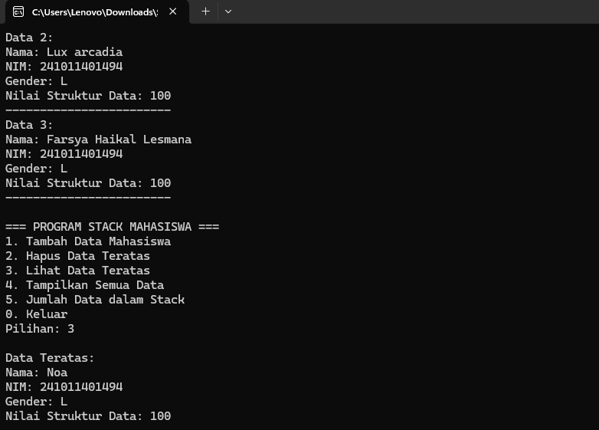

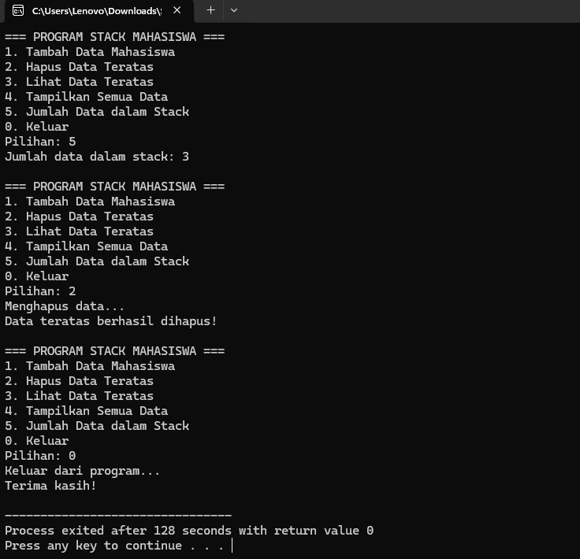

- Buat suatu program animasi Stack yang menggunakan Linked List tanpa Head untuk mengelola data mahasiswa dengan struktur mahasiswa sbb : NAMA, NIM, GENDER, NILAI STRUKTUR DATA. Program dibuat dalam bentuk menu dengan pilihan : INSERT DATA, HAPUS DATA, CETAK DATA, EXIT.

Contoh program:
#include <iostream>
#include <string>
#include <windows.h>
#include <limits>
using namespace std;

struct Mahasiswa {
string nama;
string nim;
char gender;
float nilaistrukdat;
Mahasiswa* next;
};

class Stack {
private:
Mahasiswa* top;
int size;

public:
Stack() {
top = NULL;
size = 0;
}

~Stack() {
while (!isEmpty()) {
pop();
}
}

bool isEmpty() {
return top == NULL;
}

void push(string nama, string nim, char gender, float nilai) {
system("cls");
cout << "=== INSERT DATA ===" << endl;
cout << "Memasukkan data ke stack..." << endl;

for(int i = 0; i < 3; i++) {
cout << "Membuat node baru";
for(int j = 0; j <= i; j++) cout << ".";
cout << endl;
Sleep(300);
system("cls");
cout << "=== INSERT DATA ===" << endl;
cout << "Memasukkan data ke stack..." << endl;
}

Mahasiswa* newMahasiswa = new Mahasiswa;
newMahasiswa->nama = nama;
newMahasiswa->nim = nim;
newMahasiswa->gender = gender;
newMahasiswa->nilaistrukdat = nilai;

cout << "Mengisi data ke node..." << endl;
Sleep(500);

cout << "Menyambungkan node ke stack";
for(int i = 0; i < 3; i++) {
cout << " ->";
Sleep(400);
}
cout << " [TOP]" << endl;

newMahasiswa->next = top;
top = newMahasiswa;
size++;

Sleep(800);
cout << "\nData berhasil ditambahkan ke stack!" << endl;
cout << "Nama: " << nama << endl;
cout << "NIM: " << nim << endl;
system("pause");
}

void pop() {
if (isEmpty()) {
cout << "Stack kosong! Tidak ada data yang dapat dihapus." << endl;
system("pause");
return;
}

system("cls");
cout << "=== HAPUS DATA ===" << endl;
cout << "Menghapus data dari stack..." << endl;

cout << "Data yang akan dihapus:" << endl;
cout << "Nama: " << top->nama << endl;
cout << "NIM: " << top->nim << endl;
cout << "Gender: " << top->gender << endl;
cout << "Nilai: " << top->nilaistrukdat << endl;

cout << "\nProses penghapusan:" << endl;

cout << "Memutuskan link";
for(int i = 0; i < 3; i++) {
cout << ".";
Sleep(400);
}
cout << " [DONE]" << endl;

Mahasiswa* temp = top;
top = top->next;

cout << "Menghapus memori";
for(int i = 0; i < 3; i++) {
cout << ".";
Sleep(400);
}
cout << " [DONE]" << endl;

delete temp;
size--;

Sleep(800);
cout << "\nData berhasil dihapus dari stack!" << endl;
system("pause");
}

void display() {
system("cls");
cout << "=== CETAK DATA ===" << endl;

if (isEmpty()) {
cout << "Stack kosong!" << endl;
system("pause");
return;
}

cout << "Memuat data dari stack..." << endl;

for(int i = 0; i < 3; i++) {
cout << "Mengakses node";
for(int j = 0; j <= i; j++) cout << ".";
cout << endl;
Sleep(500);
system("cls");
cout << "=== CETAK DATA ===" << endl;
cout << "Memuat data dari stack..." << endl;
}

system("cls");
cout << "=== DATA MAHASISWA DALAM STACK ===" << endl;
cout << "Jumlah data: " << size << endl;
cout << "==================================" << endl;

Mahasiswa* current = top;
int counter = 1;

while (current != NULL) {
cout << "\n--- Data " << counter << " (TOP + " << (counter-1) << ") ---" << endl;
cout << "Nama : " << current->nama << endl;
cout << "NIM : " << current->nim << endl;
cout << "Gender : " << current->gender << endl;
cout << "Nilai Struktur Data: " << current->nilaistrukdat << endl;

if (current->next != NULL) {
cout << " ?" << endl;
cout << " next" << endl;
} else {
cout << " ?" << endl;
cout << " NULL (BOTTOM)" << endl;
}

current = current->next;
counter++;
Sleep(300);
}

cout << "\n==================================" << endl;
cout << "TOP ? Data teratas stack" << endl;
system("pause");
}

int getSize() {
return size;
}
};

void clearInputBuffer() {
cin.clear();
cin.ignore(numeric_limits<streamsize>::max(), '\n');
}

void showHeader() {
system("cls");
cout << "==================================" << endl;
cout << " PROGRAM STACK MAHASISWA " << endl;
cout << " Linked List tanpa Head " << endl;
cout << "==================================" << endl;
}

int main() {
Stack stack;
int pilihan;

do {
showHeader();
cout << "\nMenu Utama:" << endl;
cout << "1. INSERT DATA" << endl;
cout << "2. HAPUS DATA" << endl;
cout << "3. CETAK DATA" << endl;
cout << "4. EXIT" << endl;
cout << "Pilihan: ";
cin >> pilihan;

switch(pilihan) {
case 1: {
string nama, nim;
char gender;
float nilai;

showHeader();
cout << "\n=== INSERT DATA ===" << endl;
clearInputBuffer();

cout << "Masukkan Nama: ";
getline(cin, nama);
cout << "Masukkan NIM: ";
getline(cin, nim);
cout << "Masukkan Gender (L/P): ";
cin >> gender;
cout << "Masukkan Nilai Struktur Data: ";
cin >> nilai;

stack.push(nama, nim, gender, nilai);
break;
}
case 2:
stack.pop();
break;
case 3:
stack.display();
break;
case 4:
showHeader();
cout << "\nKeluar dari program..." << endl;
cout << "Membersihkan stack";
for(int i = 0; i < 3; i++) {
cout << ".";
Sleep(500);
}
cout << "\nTerima kasih!" << endl;
Sleep(1000);
break;
default:
cout << "Pilihan tidak valid!" << endl;
Sleep(1000);
break;
}
} while (pilihan != 4);

return 0;
}

Hasil Output:
